Business Blueprint
AOP Automation FOR MEG PlanT
  Site Name | Reliance Industries Ltd.
Track Name | RIL AOP Automation for MEG Plant
Rev. No. | Rev 5
Rev. Date | 02-06-2025
Honeywell Doc No.
RIL Doc No.


Business Blueprint

AOP Automation for MEG Plant

Prepared for:
Reliance Industries Ltd

Submitted by:
Honeywell Automation India Ltd (“Honeywell”)

Revision History

Rev. | Date | Originated By | Description of status and changes
0.0 | 12-Nov-2024 | HON | Issued for Review
1.0 | 30-Jan-2025 | HON | Issued for Review
2.0 | 06-Feb-2025 | HON | Issued for Review
3.0 | 14-Feb-2025 | HON | Issued for Revied (RIL comments included)
5.0 | 02-June-2025 | HON | Issued for Approval

Table of Contents
1. Introduction 6
1.1 Executive Summary 6
1.2 Reference Documents 7
2. Workshop Details 8
3. AOP Design Basis 9
3.1 Process and Operations Function 9
3.1.1 Budget Production/Production AOP 10
3.1.2 Norms 17
3.1.3 Feedstock Availability 23
3.1.4 Other Cost (To generate cost sheet - Business) 23
4. AOP Solution Overview/Output 24
5. Key Assumptions and Exemptions 25

List of Figures
Figure 1 Digitized AOP Flow Diagram 9
Figure 2 Digitized AOP screen for Configuration/manual Inputs 10
Figure 3 Digitized AOP Steps to derive EOE and EO month wise MC values 11
Figure 4 Digitized AOP screen for MEG Yield 11
Figure 5 Digitized AOP screen for Production Volume data 12
Figure 6 Digitized AOP screen for Business Demand 12
Figure 7 Digitized AOP screen for Shutdown/Turnaround Activities 13
Figure 8 Digitized AOP screen for Slowdown Activities 13
Figure 9 AOP Maintenance Details Table 15
Figure 10 Digitized AOP screen for Production AOP month wise 16
Figure 11 Digitized AOP Steps to derive month wise Historical Best Norms 17
Figure 12 Example of selectivity Extrapolation 18
Figure 13 Digitized AOP screen for Catalyst Selectivity month wise 19
Figure 14 Digitized AOP screen for Normal operations Norms 19
Figure 15 Digitized AOP screen for Shutdown Norms 21
Figure 16 Digitized AOP screen for Shutdown Norms 21
Figure 17 Digitized AOP screen for Budget Norms or Consumption Norms 22
Figure 18 Digitized AOP screen for Feed Stock Availability 23

List of Tables
Table 1 Reference Documents 7
Table 2 List of MEG vertical Plants 8
Table 3 AOP Functional Scope 9
Table 4 Maintenance Details 14
Table 5 Raw Material Norms calculations 18

Introduction
The purpose of this document is to capture the detailed specifications for the Digitalized Annual Operating Plan (AOP) for MEG technology plants across RIL sites.
This document is based on the Technical Proposal submitted by Honeywell to Reliance. It also refers to data collected during the workshop conducted at RCP with various MEG plant users across RIL sites.

Executive Summary
Reliance Industries Limited is India’s leading private sector organization operating in various business verticals. The manufacturing sector is one such business vertical. RIL owns and operates multiple plants across various sites.
Defining and finalizing the Annual Operating Plan is a critical annual business process carried out by different functional teams. At present, this activity is carried out manually.
A Rev-0 budget is usually completed in Nov / Dec for the succeeding Financial Year (FY) and reviewed. The comments are addressed with updated information from the Business, as the next revised budget is expected by the end of January. Further revisions (if any) are incorporated in Feb / March to reflect updated business input as applicable.
The entries from the final rev of the budget are finalized in BPC before the beginning of the succeeding FY.
RIL aims to automate the AOP preparation process using a Data-Driven Model. This model leverages the last five years of AOP data from MIIS and incorporates plant-specific business rules (such as plant availability, running hours, feedstock availability, seasonal impact on production, etc.) to derive AOP figures in the expected formats.
As part of digitalization, Honeywell will support building a platform that will automate the Annual Operations Planning process for MEG technology.

Reference Documents
Document ID | Revision | Title | Document
O-836243B24R01 | R01 | AOP Automation for O2C Proposal
Workshop MOM | - | MEG_Norms_Steps
MEG DCT | - | DCT for EOEG Digital AOP
Table 1 Reference Documents

Workshop Details
HON conducted a workshop along with the RIL MEG technology teams dated 7th and 8th Oct 2024.
During this workshop, current practices followed for the development of an AOP plan for the process and operation function, of respective sites/plants for a financial year were identified.
The summary of details discussed with the RIL team is captured in the Excel (MEG_Norms_Steps) provided in the reference document table.
The MEG vertical consists of the below plants for digitized AOP preparation
Sr. No. | Sites for MEG | Plants | Workshop Participants
1 | C2 | MEG | Site/COE Team
2 | DMD | EOEG | Site/COE Team
3 | HMD | MEG 1 | Site/COE Team
4 | HMD | MEG 2 | Site/COE Team
5 | HMD | MEG 3 | Site/COE Team
6 | NMD | EOEG | Site/COE Team
7 | VMD | EOEG | Site/COE Team
Table 2 List of MEG vertical Plants

AOP Design Basis
The table below captures different functions for the scope of AOP digitization design –
Sr. No. | Functions | Covered in Document
1. | Health, Safety and Environment (HSE) | For later release, post review and discussion
2. | Process/Operations | Covered
3. | Reliability and Maintenance | For later release, post review and discussion
Table 3 AOP Functional Scope
Function-wise, the detailed design basis is captured in the sections below.

Process and Operations Function
In this section, the budgeted Production and Norms for a plant are derived, using a standard approach as briefed in the sections below for the following criteria
- Budget Production/Production AOP
- Norms/Consumption AOP
Steps to generate the Production and Consumption AOP are captured in the below flow diagram.

Figure 1 Digitized AOP Flow Diagram

Budget Production/Production AOP
Below are the steps captured to derive the budgeted AOP production values.

Configuration
The configuration screen serves as the foundation for the digital AOP process, allowing users to input essential data for production and consumption AOP calculations.
Plant-specific data, including Yield, Selectivity, and Consumption, are configured under the Configuration screen to support Production and Consumption Norms calculations and reports generation.
By default, the values entered for the current year will be automatically carried forward to the next year.
The user must insert the TST value month wise and save it with a valid reason. This will provide the Latent heat against TST.
Note - Latent heat will be calculated only if the user provides the correct pressure input corresponding to the TST temperature; otherwise, the latent heat value will be set to 0.
The screenshot below highlights the details captured in the digitized AOP platform–
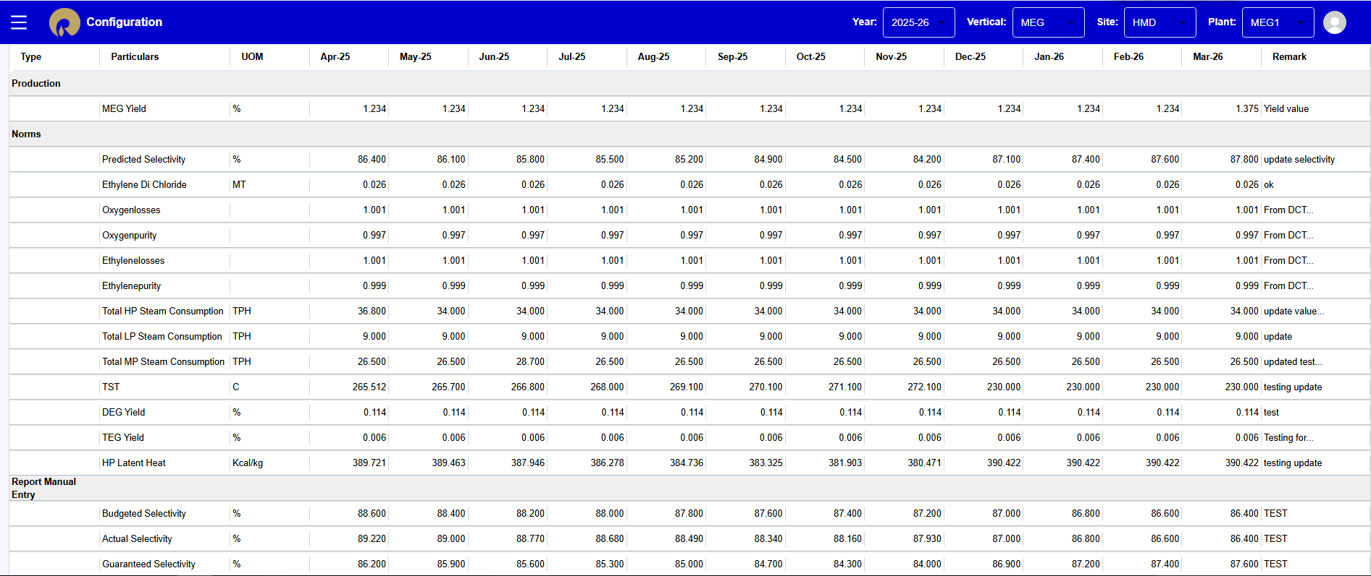
Figure 2 Digitized AOP screen for Configuration/manual Inputs

Production Volume Data
The Max Capacity (MC) of EOEG plants is defined on an EOE basis.
MC values for Ethylene Oxide (EO), Ethylene Oxide Equivalent (EOE) and Monoethylene Glycol (MEG) will be captured separately.

Month wise data is considered for deriving the best value. This will account for seasonal effects as well as the festive season.

Value estimation involves averaging production data over continuous 5-day periods in the last 5 years, after removing outliers. For each month, 5 such averages are calculated, and the maximum value from the highest average set is designated as the MC value or production volume.

A similar approach is employed for calculating the EO MC value.

The following logic has been formulated to derive month-wise EOE and EO MC values.

Figure 3 Digitized AOP Steps to derive EOE and EO month wise MC values

The MEG MC value is determined using the following formula.

$$MEG MC = MEG Yield*(EOE MC-EO MC)$$

Where MEG yield is a month-wise manual entry captured in the AOP digitization portal in the Configuration screen, as seen in the screenshot below.

Figure 4 Digitized AOP screen for MEG Yield

If the user needs to modify the production rate this can be done by providing a specific reason.

The AOP digitization portal captures a month-wise percentage summary, comparing each month's value against the highest MU value recorded over the past 12 months.

This information is captured in the AOP digitization portal as seen in the screenshot below.

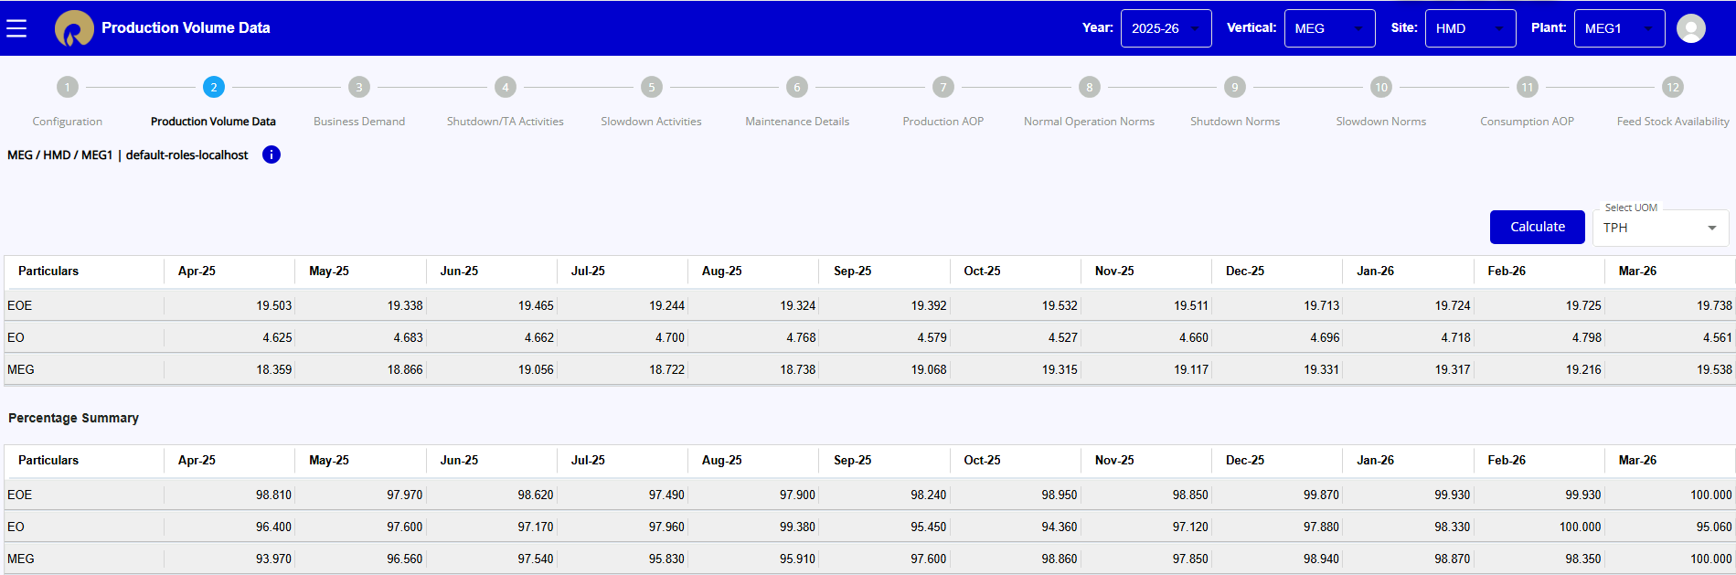
Figure 5 Digitized AOP screen for Production Volume data
The 'Calculate' button on this screen allows the user to compute the MEG MC value if any changes have been made to the MEG Yield on the configuration screen.

Business Demand
The production demand is considered as the maximum value from last year's achieved production values. The default value for EOE, EO and MEG is 100%.
The business demand value can be modified by users upon providing a specific reason.
This information is captured in the AOP digitization portal as seen in the screenshot below.
NOTE: For the HMD MEG1, NMD and VMD plants, the CO2 demand will be captured in this section.
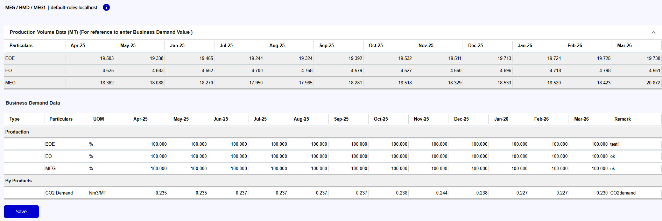
Figure 6 Digitized AOP screen for Business Demand

Maintenance/Shutdown/Slowdown/TA Activities
The operations team will provide the shutdown, turnaround and slowdown plan to calculate month-wise operating hours available for production.
The below screenshot depicts the shutdown and turnaround activities planned, as will be captured in the AOP digitized platform.
The user has to enter the SD-From and SD-To date and time to calculate the duration in hours, or SD-From and Duration(hrs) to calculate the SD-To date/time.
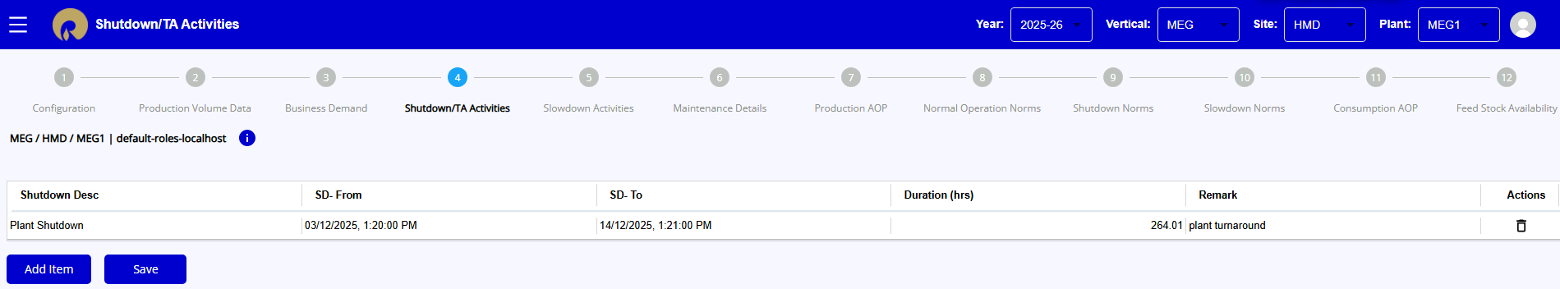
Figure 7 Digitized AOP screen for Shutdown/Turnaround Activities
The Slowdown entries will have the inputs as shutdowns, along with the requirement of plant EOE/EO load (TPH basis) for the duration of the slowdown.
The slowdown activities can be calculated based on the slowdown rate and hours. This is called a Basis Shutdown, equivalent to Shutdown.
$$Basis shutdown equivalent of Slowdown hrs = (Slowdown rate(TPH) * Slowdown hrs) / MCU$$
For each shutdown entry, four slowdown entries will be generated automatically, with the nomenclature as “#Shutdown Entry name. – Ramp down” and “#Shutdown Entry name. – Ramp Up”, two for each EO and EOE.

The below screen depicts the slowdown activities planned which is captured in the digitized platform.
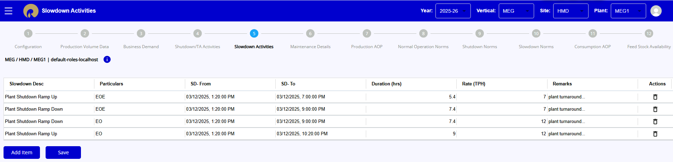
Figure 8 Digitized AOP screen for Slowdown Activities

The 'Add Item' button on the screens allows users to insert a new entry for shutdown, turnaround, or slowdown.
The 'Save' button enables users to save newly added items as well as any modifications made to existing entries.
Using this data, the number of operating hours available in a month is calculated as -
$Number of Operating Hours in a month = Total Number of hrs in a month – (Shutdown Hrs + Slowdown converted to equivalent Shutdown Hrs)$
For each month, the following table is generated based on all inputs for shutdowns/slowdowns-

Description | April | … | March
Total Available Hours for the Month | 30*24=720
Shutdowns Hours | From the Routine Shutdown Plan Section
Non-Shutdown Operating Hours for the Month | $$Total Available operating hours for the month-Shutdown hrs$$
Average Slowdown Load/rate for EOE, % of Production Volume Target (PVT) | $$\frac{\sum_{i=1}^{n}{{(EOE slowdown hrs}_{i}×{EOE load/rate during slowdown}_{i})}}{\sum_{i=1}^{n}{{(EOE slowdown hrs}_{i}) ×EOE MC for Month}}$$
Average Slowdown Load/rate for EO, % of Production Volume Target (PVT) | $$\frac{\sum_{i=1}^{n}{{(EO slowdown hrs}_{i}×{EO load/rate during slowdown}_{i})}}{\sum_{i=1}^{n}{{(EO slowdown hrs}_{i}) ×EO MC for Month}}$$
EOE Slowdown Load/rate Reduction as Shutdown Hours Equivalent | $EOE Average slowdown load/rate, \% of PVT × \sum_{i=1}^{n}{{(EOE slowdown hrs}_{i})}$
EO Slowdown Load/rate Reduction as Shutdown Hours Equivalent | $EO Average slowdown load/rate, \% of PVT × \sum_{i=1}^{n}{{(EO slowdown hrs}_{i})}$
EOE Effective Operating Hours @ PVT | $$Total Available operating hours for the month-Shutdown/TA hours-EOE Slowdown load reduction as Shutdown hours Equivalent\left(other reasons\right)+EOE Slowdown load reduction as Shutdown hours Equivalent(Rampup/RampDown)$$
EO Effective Operating Hours @ PVT | $$Total Available operating hours for the month-Shutdown/TA hours-EO Slowdown load reduction as Shutdown hours Equivalent\left(other reasons\right)+EO Slowdown load reduction as Shutdown hours Equivalent(Rampup/RampDown)$$
Table 4 Maintenance Details

The screen below depicts the Maintenance Details Table, which is captured in the digitized platform.
NOTE: The below screen is read-only. The users cannot change the values.
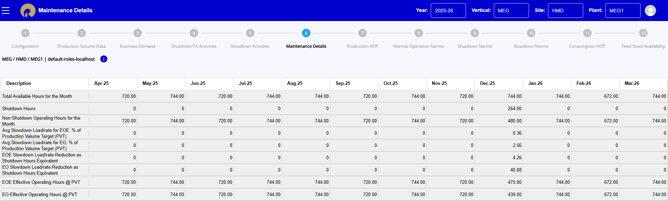
Figure 9 AOP Maintenance Details Table

Calendar Year Based Production Calculations Details/Production AOP
Using the Business Demand, Production Volume data and Maintenance Plan (Operating Hours), the month-wise production quantity is derived.
The month-wise budget production for each product is calculated in MT and KT, the formula for which is mentioned below.

$Production AOP (MT) =(Operating hours in a month (hrs) * Percentage of product demand * MC Value of product(TPH)) / 100$

$Operating hours for MEG = Total Available hours of the month – Shutdown/TA hours of the month$

$Operating hours for EOE = Total Available operating hours for the month - Shutdown/TA hours - EOE Slowdown load reduction as Shutdown hours Equivalent (other reasons) + EOE Slowdown load reduction as Shutdown hours Equivalent (Ramp up/Ramp Down)$

$Operating hours for EO = Total Available operating hours for the month - Shutdown/TA hours-EO Slowdown load reduction as Shutdown hours Equivalent (other reasons) + EO Slowdown load reduction as Shutdown hours Equivalent (Ramp up/Ramp Down)$
Hence, month–wise production is,
$$Total Budgeted Production = ∑All the values for the month$$

The month-wise budget production is further used to derive the annual plan in KT, and this is part of the final report.

This information is captured in the AOP digitization portal as seen in the screenshot below.

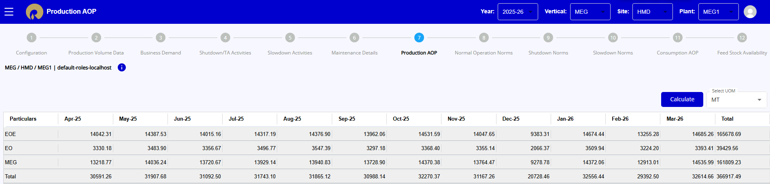
Figure 10 Digitized AOP screen for Production AOP month wise

The ‘Calculate’ button on this screen allows users to recalculate Production values when changes are made to configuration settings (e.g., MEG yield), business demand, or when line items are added to slowdown and shutdown activities.

Norms
Below are the steps captured to derive the Norms value.

Normal Operation Norms
All the specific consumption norms are set with One-unit EOE as the basis.
For calculation purpose in the Digitized AOP platform, based on the DCT provided by the user, Norms are broadly classified as –
- Historical Best
- Based on Calculations
- Manual Entries

3.1.2.1.1 Historical Best
Based on the historical data of last 5 years, corresponding to the MCU production, the best-achieved feed slate period is filtered. This data is further used for the calculation of consumption norms, which is the average of the norms during that period, excluding the identified outliers.

Below is the logic formulated to derive the Historical best Normal Operation Norms –

Figure 11 Digitized AOP Steps to derive month wise Historical Best Norms

The user has provision to overwrite/update the value by providing a valid reason for the historical best particulars. This overwritten value, if any, will be highlighted in RED color.
The list of particulars to be derived using the Historical Best logic is specified in the DCT provided by the user. These particulars may vary from plant to plant.

3.1.2.1.2 Based on Calculations
For the MEG vertical, particulars like ethylene, oxygen, HP Steam, BFW water etc. are formulated based on the stoichiometric calculations provided by the user in the DCT.
The formula can vary from plant to plant.
E.g. the Raw Material norms for ethylene and oxygen for HMD MEG1 are derived using the calculations mentioned in the below table.

Plant | Category | Particular | Calculation
HMD MEG1 | Raw Material | Ethylene | (((EOE Losses for ethylene*28*100/44/{selectivity})+([METHANE Norms]*28*0.28/16/0.54))/Ethylene Purity)+(0.135/24/([EOE]/[EOE Op hrs]))
 |  | Oxygen | (EOE Losses for oxygen*(100*2.1818/{selectivity}-1.818)+([METHANE Norms]*32*0.05/16/0.54))/Oxygen Purity
Table 5 Raw Material Norms calculations

The values for losses and purity can be captured from the Lab analysis or Past/last year's operations. The user has the provision to enter the value manually in the Configuration screen.
Selectivity is defined as the efficiency of the catalyst. The data for selectivity will be extrapolated based on the previous year’s data till the end of the catalyst run (EOR). The user will have an additional capability to insert the data whenever the catalyst changeover takes place. This is a need as there is no previous data for the catalyst selectivity during the start of the run (SOR).
The image below is for reference.
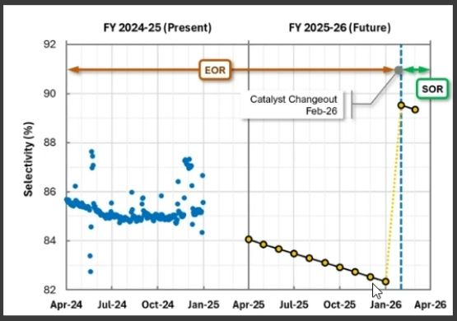
Figure 12 Example of selectivity Extrapolation
Selectivity, Losses and Purity can be modified/added by the user in the Configuration Screen under the Norms Subsection.
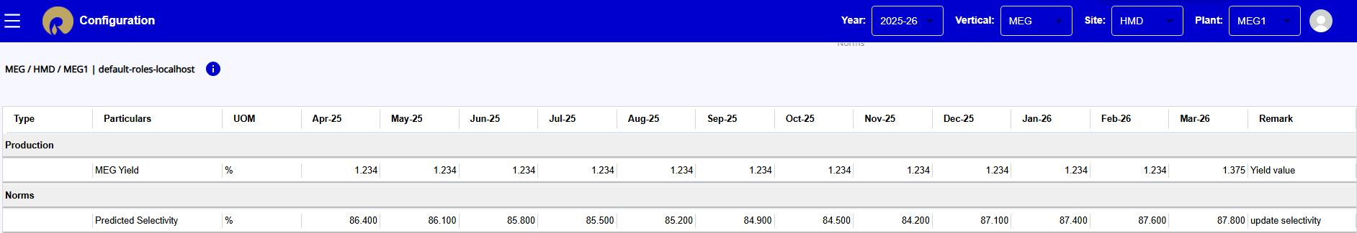
Figure 13 Digitized AOP screen for Catalyst Selectivity month wise
In the Normal Operations Norms screen the cells for particulars with formula, e.g. HP Steam Dis, will be read only. If the values for such particulars are to be modified then the respective inputs should be modified, e.g. Total HP Steam consumption in the Configuration Screen.

3.1.2.1.3 Manual Entries
The particulars under the Chemicals and Catalyst sections are manually entered by the user, who must also provide the corresponding norm values in the Normal Operation Norms screen.
The screenshot below highlights the details captured in the digitized AOP platform in the Normal Operations Norms screen.
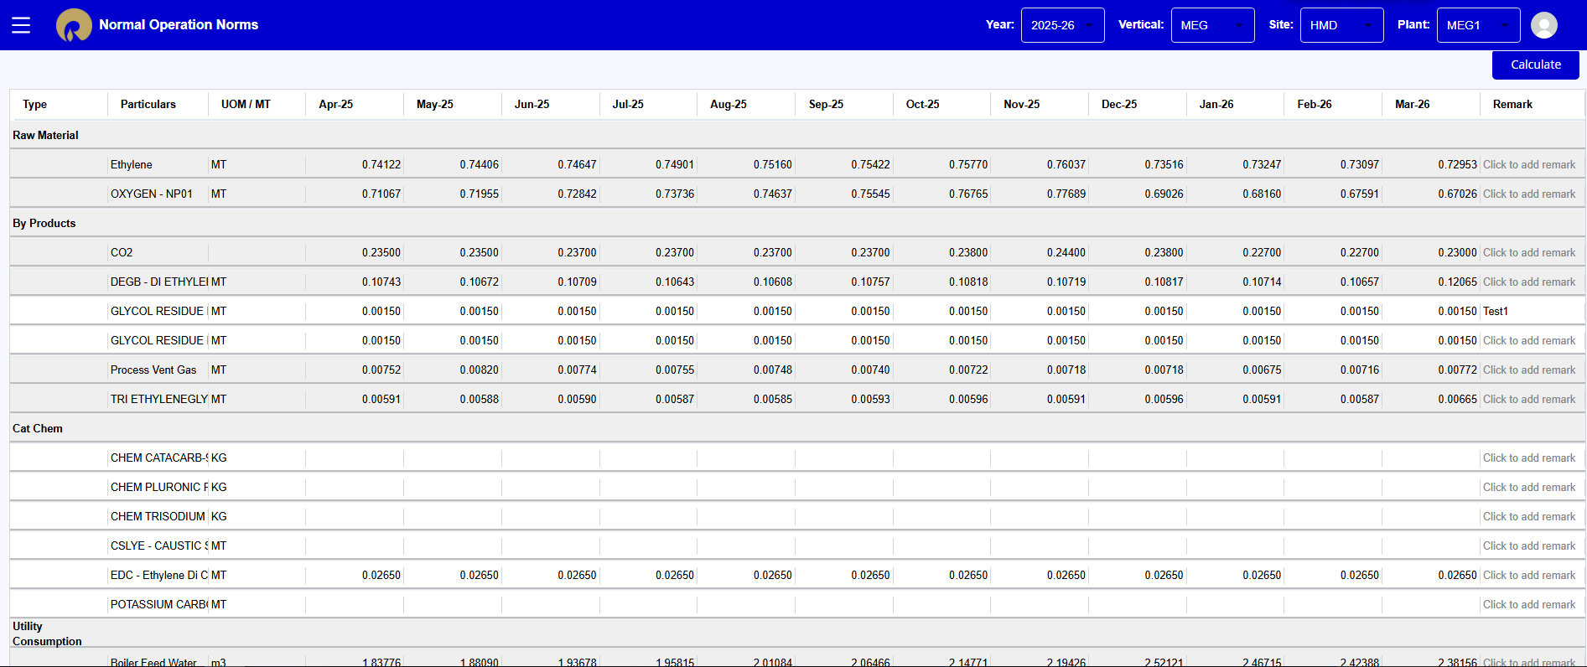
Figure 14 Digitized AOP screen for Normal operations Norms

The Normal Operation Normas screen also captures the Intermediate calculations required for Norms calculation as shown in the below screen shot –
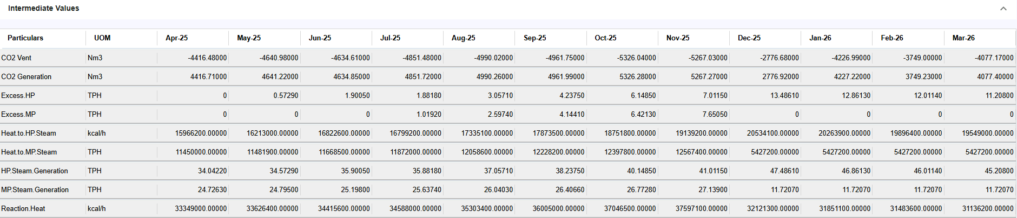
The ‘Calculate’ button on the screen will enable if the user makes any change in the dependent inputs in the Configuration screen or overwrite the norms values like Methane used in other norms calculations.
The ‘Save’ button on the above screen enables the user to save any norm value updated manually for historical best norms or any calculated value.

Shutdown Norms
The Shutdown norms are recorded for the months in which shutdown activities are planned, as specified in the Shutdown Activities screen.
The shutdown quantity utilization data includes TA, asset maintenance linked shutdown/ slowdown activities, etc..
The use must enter the consumption data (absolute values) for each line item.
The below screenshot depicts the Shutdown Norms captured in the AOP digitized platform.

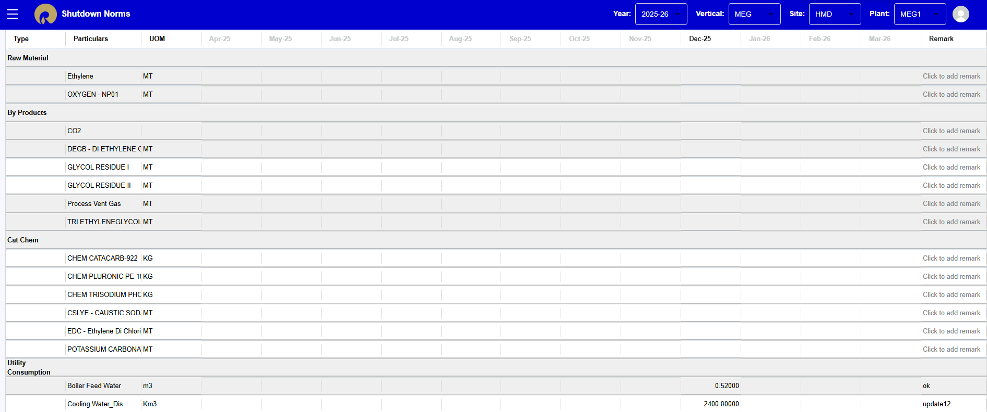
Figure 15 Digitized AOP screen for Shutdown Norms

Slowdown Norms
Slowdown norms are recorded for the months in which slowdown activities are planned, as specified in the Slowdown Activities screen.
The values for slowdown norms are same as the Normal Operations norms for the month.
The below screenshot depicts the Shutdown Norms captured in the AOP digitized platform.

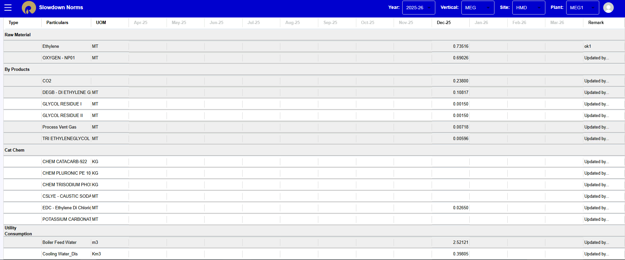
Figure 16 Digitized AOP screen for Shutdown Norms

Budget Norms/Consumption AOP
Using the values of Normal operations Norms, Shutdown Consumptions and Slowdown Norms, the final Consumption AOP value is calculated as below –
$$Consumption AOP for months without shutdown or slowdown = Normal Operations Norms$$
$Consumption AOP for months with shutdown or slowdown = Total Consumption/Total production$
Where,
$Total Consumption = (Normal Operation Norms*EOE MC value*EOE operating hours)+\sum_{i=1}^{n}{{(Slowdown Norms*EOE slowdown hours*EOE slowdown rate)}_{n}}+Shutdown Consumption$
$Total Production = (EOE MC value*EOE operating hours)+\sum_{i=1}^{n}{{(EOE slowdown hours*EOE slowdown rate)}_{n}}$
The below screenshot depicts the Shutdown Norms captured in the AOP digitized platform.
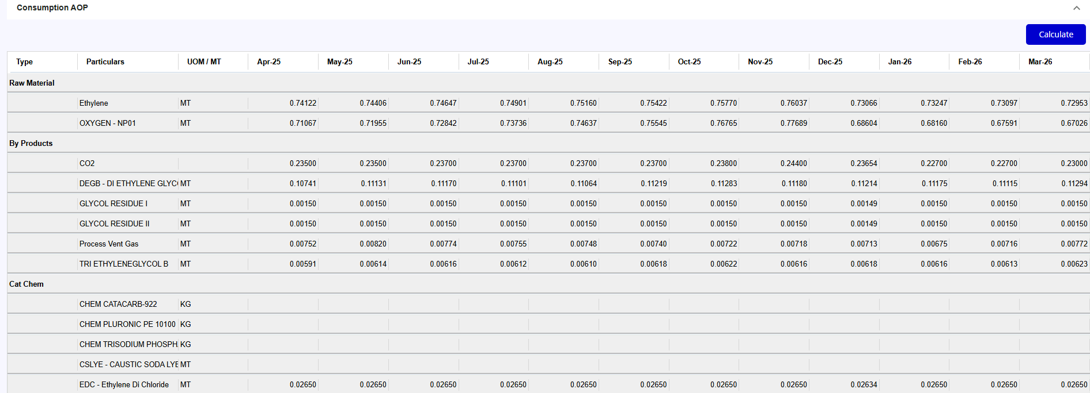
Figure 17 Digitized AOP screen for Budget Norms or Consumption Norms

Feedstock Availability
Availability of Feedstock/Raw Material defines maximum attainable production in a plant.
In the case of MEG technology, the availability of Ethylene and Oxygen will be accounted for planning of unit production.

For the Rev 0 for AOP production/norms will consider the 100% availability of the required.

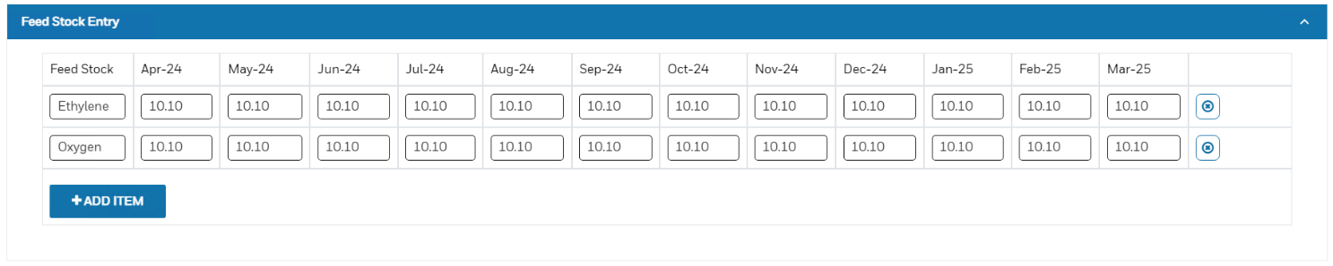
Figure 18 Digitized AOP screen for Feed Stock Availability

- These quantities will be compared against feedstock requirements and used for optimizing the production to meet the constrained feedstock availability as per below mentioned logic.
Reduced No of Operating Hrs to Maximize the production by making Delta Feedstock (difference of Available and Required feedstock) = 0

Other Cost (To generate cost sheet - Business)
- Process consumables will be discussed with RIL and TBD for a path forward.
- Maintenance consumables will be discussed with RIL and TBD for a path forward.

AOP Solution Overview/Output
- Rev 0 - Budgeted Production and Norms.
- Excel Tables outputs – List and end-state views are required.
- Final format of AOP budget to be uploaded in BPC.
- Plant-wise Basis report for APEX review.
- Annual AOP Cost Report.
- Plant Production Summary.
- Month wise Production Plan.
- Month wise Raw data.
- Turnaround Report.
- Annual Production Plan.
- Planned Contribution.

Key Assumptions and Exemptions
The above scope of work should be read with the following assumptions made
- Data Acceptance
- DCT provided by RIL team

